GLRLMS {mean of 4 angles} (11) + GLCM (20) + Hu moments (7);

No variables excluded; no PCA; classes 1&2 and 3&4 lumped

Tumor slides resized to 75*75 pixels & 10-fold cross-validation

1. Best classifier: KNN (k=1)

Accuracy = **94.8%**

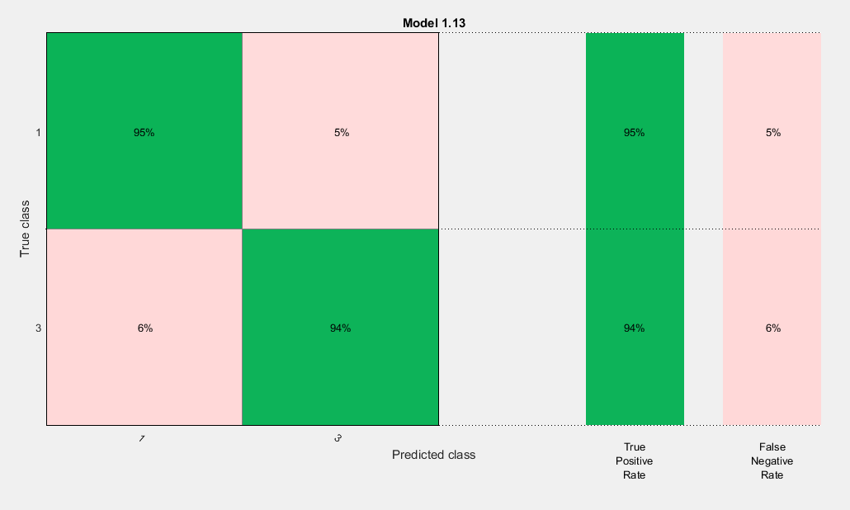

1. Best classifier: KNN (k=1)

Accuracy = **93.5%**

1. Best classifier: KNN (k=1)

Accuracy = **92.2%**

1. Best classifier: KNN (k=1)

Accuracy = **92.2%**

1. Best classifier: KNN (k=1)

Accuracy = **96.1%**

**Average accuracy = 93.37%**

Tumor slides resized to 75*75 pixels & n-1 cross-validation

1. Best classifier: KNN (k=1)

Accuracy = **94.8%**



1. Best classifier: KNN (k=1)

Accuracy = **94.8%**

1. Best classifier: KNN (k=1)

Accuracy = **93.5%**

1. Best classifier: KNN (k=1)

Accuracy = **94.8%**

1. Best classifier: KNN (k=1)

Accuracy = **94.8%**

**Average accuracy = 94.54%**

10-fold cross-validation

|  |  |
| --- | --- |
| **75*75 pixels** | **100*100 pixels** |
| KNN – 90.9% | KNN – 90.9% |
| KNN – 94.8% | KNN – 94.8% |
| KNN – 94.8% | KNN – 94.8% |
| KNN – 92.2% | KNN – 92.2% |